Use K-Means Clustering to classify tweets in RapidMiner

Abstract
With the advancement of web technology, the amount of text that is generated every day is increasing dramatically in the web for internet users. Internet is a platform for online learning, exchanging ideas and sharing opinions. Social Networking sites such as Twitter, Facebook, Google+ are quickly picking up notoriety as they permit people to share and express their views about topics, have discussion with distinctive communities, or post messages over the world .These tremendous volumes of unstructured data cannot be processed simply. Hence, effective methodologies and algorithms are required to discover useful patterns. Text Mining is the process of extracting meaningful information from pattern.
In the recent years, social networks in business are gaining ubiquity because of their potential for business development. Companies can know more about customer sentiments towards their products and services and use it to better understand the market and improve their brand. Therefore, companies regularly reinvent their marketing strategies and campaigns to fit consumer’s preferences. This report selected a popular key word to evaluate a given stream of customer comments on twitter. For analysis many metrics in classification and clustering of data are used. A twitter API is used to collect twitter corpus. A K-means clustering technique is used to group together similar words in tweets in order to obtain business value. This report attempts to discuss the technical and commercial perspective of the Text mining analysis of Twitter data and relevant opportunities for the development of this emerging field are recommended.

Introduction
NLP is a very broad topic and includes a huge amount of subdivisions: Natural Language Understanding, Natural Language Generation, Knowledge Base building, Dialogue Management Systems (and Intelligent Tutor Systems in academic learning systems), Speech Processing, Data Mining – Text Mining – Text Analytics, and so on. Text Analytics is the most recent name given to Natural Language Understanding, Data and Text Mining. Unstructured free text accounts for 80% in a business context, including tweets, blogs, wikis and surveys. Text Analytics is the discovery of new, previously unknown information, by automatically extracting information from different written resources. Text Analytics, also known as Intelligent Text Analysis, Text Data Mining or Knowledge-Discovery in Text (KDT), refers generally to the process of extracting non-trivial information and knowledge from unstructured text. Text Analytics is similar to data mining, except that data mining tools are designed to handle structured data from databases, either stored as such or as a result from pre-processing unstructured data. Text Analytics can cover unstructured or semi-structured data sets such as emails, full-text documents and HTML files, blogs, newspaper articles, academic papers, etc. Text Analytics is an interdisciplinary field which draws on information extraction, data mining, machine learning, statistics and computational linguistics. The multidisciplinary nature of Text Analytics is key to understand the complex integration of different expertise: computer engineers, linguists, experts in Law, Biomedicine or Finance, data scientists, psychologists, causing that the research and development approach is fragmented due to different traditions, methodologies and interests. A typical text analytics application consists of the following steps and tasks: Starting with a collection of documents, a text mining tool retrieves a particular document and pre-process it by checking format and character sets. Then it would go through a text analysis phase, sometimes repeating techniques until information is extracted. The underlying strategy in all the components is to find a pattern (from either a list or a previous process) which matches a rule, and then to apply the rule which annotates the text. Each component performs a particular process on the text, such as: sentence segmentation (dividing text into sentences); tokenization (words identified by spaces between them); part-of-speech tagging (noun, verb, adjective, etc., determined by look-up and relationships among words); shallow syntactic parsing/ chunking (dividing the text by noun phrase, verb phrase, subordinate clause, etc.); named entity recognition (NER) (the entities in the text such as organizations, people, and places); dependency analysis (subordinate clauses, pronominal anaphora [i.e., identifying what a pronoun refers to], etc.). The resulting process provides “structured” or semi-structured information to be further used (e.g. Knowledge Base building, Ontology enrichment, Machine Learning algorithm validation, Query Indexes for Question & Answer systems).
Text mining on a large collection of documents is usually a complex process, thus it is critical to have a data structure for the text which facilitates further analysis of the documents [65]. The most common way to represent the documents is as abag of words (BOW), which considers the number of occurrences of each term (word/phrase) but ignores the order. This representation leads to a vector representation that can be analyzed with dimension reduction algorithms from machine learning and statistics.
Cross Industry Standard Process for Data Mining model defines these primary steps as follows:
1) Business Understanding 2) Data Understanding 3) Data Preparation 4) Modelling 5) Evaluation 6)Deployment
These phases help organizations understand the data mining process and provides a blue print to follow. Data preparation is one of the most tedious steps, because it needs special methods to convert textual data to an appropriate format for data mining algorithms to use.

Business Understanding
Twitter, which is a social networking online service, is mainly used as a marketing and promotion tool by most companies. Specifically, twitter data contains not only user information, but also texts that contain subjective information (such as user sentiments) towards a particular issue. From a business perspective, the wealth of tweets is enough for companies to gather sufficient feedback
The social media has reclassified the idea of how companies strategize their business process. The social media about their products and services from their customers without having to spend for costly customer surveys and interviews. On the other hand, analysing and extracting information from unstructured data poses a formidable challenge to data miners. Humans can easily find patterns and trends in documents, but this ability is limited when a large amount of data is involved. However, with the help of analytical tools and techniques, such challenge is achievable.
This report demonstrates the text analysis process in reviewing the public opinion of customers towards a certain brand and presents hidden knowledge (e.g. customer and business insights) that can be used for decision making after the text analysis is performed .

Software Specification
RapidMiner is a data-driven data mining tool that discovers patterns in large collections of text . It is an analytic platform that integrates machine learning and predictive model deployment used by data scientists. It contains rich libraries of data science and machine learning algorithms . The software used in this experiment is the latest version - RapidMiner Studio Educational version 9.2.001.

Unsupervised Learning Methods:
Unsupervised learning methods are techniques trying to find hidden structure out of unlabelled data. They do not need any training phase, therefore can be applied to any text data without manual effort. The two commonly used unsupervised learning algorithms used in the context of text data are
- Clustering
- Topic Modelling
Clustering is the task of segmenting a collection of documents into partitions where documents in the same group (cluster) are more similar to each other than those in other clusters. In topic modelling a probabilistic model is used to determine a soft clustering, in which every document has a probability distribution over all the clusters as opposed to hard clustering of A Brief Survey of Text Mining: Classification, Clustering and Extraction Techniques KDD Bigdas, August 2017, Halifax, Canada documents. In topic models each topic can be represented as a probability distributions over words and each documents is expressed as probability distribution over topics. Thus, a topic is akin to a cluster and the membership of a document to a topic is probabilistic

Data Understanding
Sentiment Analysis is “a process that automates the mining of attitude, opinions, views, and emotions from text, speech, tweets, and database sources through Natural Language Processing (NLP)”. It is also referred to as opinion mining and emotion analysis. It uses textual data to analytically collect, analyse, model and validate for various business intelligence applications. Fig. 1 illustrates different approaches and techniques to sentiment analysis.

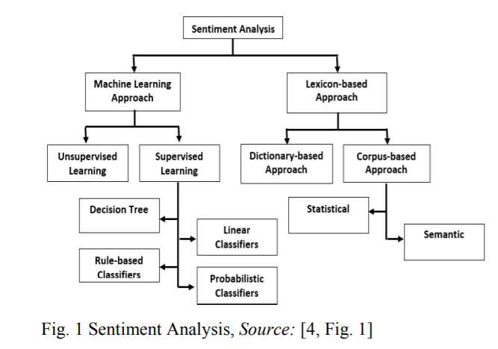

Several studies have pointed out the importance and benefits of customer sentiment analysis for business operations. Majority of the purposes are for business improvement and decision support . The study of unstructured text analytics is of good use for business for product decisions.
The study stressed the significance of information triangulation from different unstructured text sources, including newspaper articles, to create confidence in the information for critical decisions. Moreover, text analytics is used by the Information Technology Services (ITS) of Florida State University to capture the stream of incoming service requests across business units [11]. Its success in extracting insights from the texts has allowed the company to provide an effective IT service management

Data Preparation
The text classification process involves many tasks such as data extraction, data cleaning, pre-processing and feature extraction . The detailed process diagram in RapidMiner is illustrated in Fig. The processes applied to this experiment are each described in the succeeding sections.
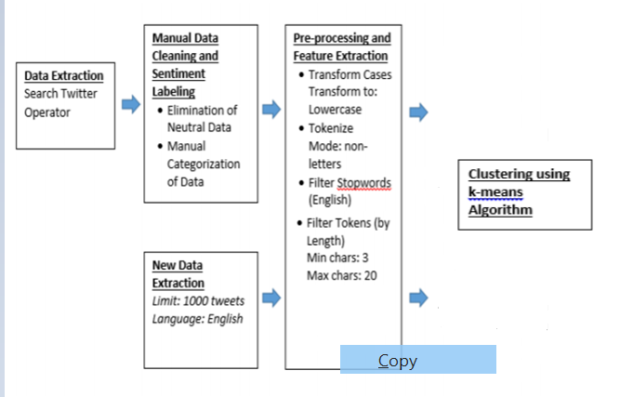

1) Data Extraction
Information Extraction from text: Information Extraction is the task of automatically extracting information or facts from unstructured or semi-structured documents. It usually serves as a starting point for other text mining algorithms. For example, extraction entities, Name Entity Recognition (NER), and their relations from text can give us useful semantic information.
Collect tweets that your interested. An access token, which is used to get authentication access to extract data from the Twitter database, is given upon logging into a Twitter account. Authorization details that include the API key are required to establish the connection and allow a search query. An example set of Twitter is generated when setting the parameters for the Search Twitter operator. In this experiment, a query parameter is configured i.e. Machine learning. Other search parameters include returned tweet and language limit of 1000 English tweets, and the result type of recent or popular tweets. This contains attribute and label types including tweet ID, username, number of retweets, original text, date and time it was created, language, and many others.

2) Manual Data Cleaning and Sentiment Labelling
The returned example set is 968 tweets with id and text columns. Collected tweets are converted into text data. Convert the collected tweets into documents that RapidMiner can process. The raw data that is collected is highly susceptible to inconsistency and redundancy. Pre-processing of tweet includes
- Remove all URL’S Regular expressions are used to eliminate URLs in the collected tweets using replace operator.
- Correct the spellings; sequence of repeated characters is to be handled
- Remove stop words
- Remove non-English tweets
- Only select tweet texts in the text processing. The Select Attributes selects attributes with no missing values

Process in Rapid Miner

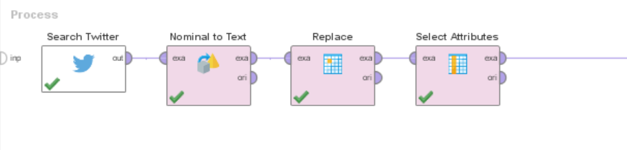
Results
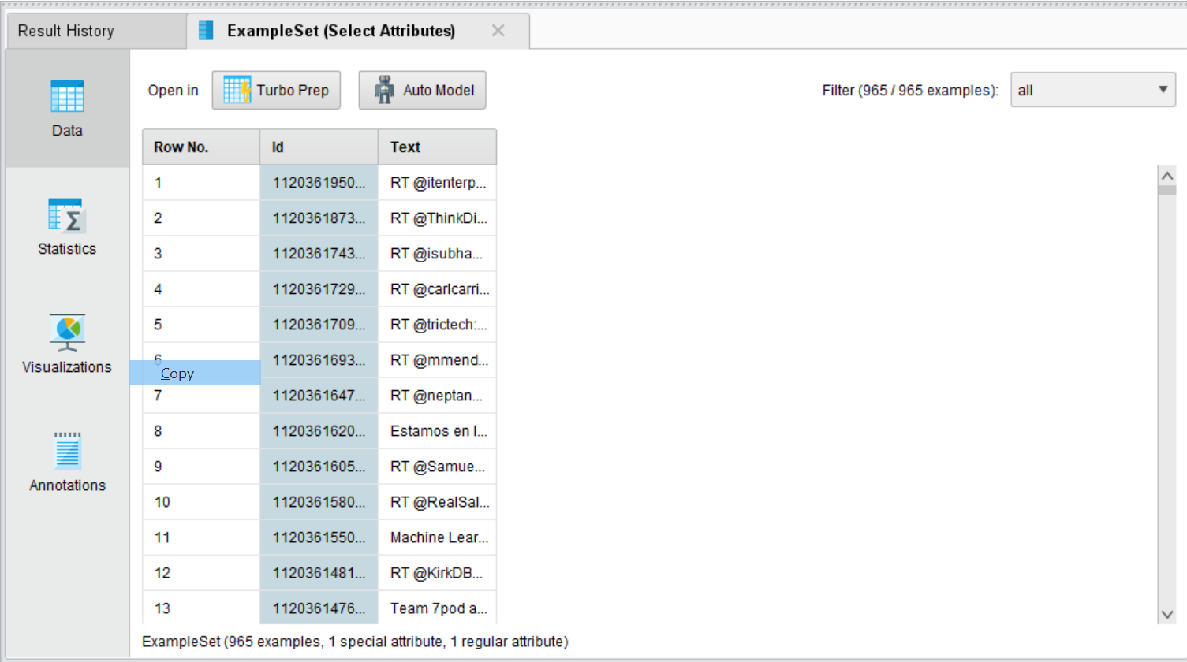

3) Feature Extraction
The pre-processed dataset has many distinctive properties. In the feature extraction method, we extract the aspects from the processed dataset .
After data cleansing, Tokenize tweets into vectors. Convert texts to vectors, convert all letters to lowercases, eliminate letters that are too short or too long, filter out stop words
Process in Rapid Miner

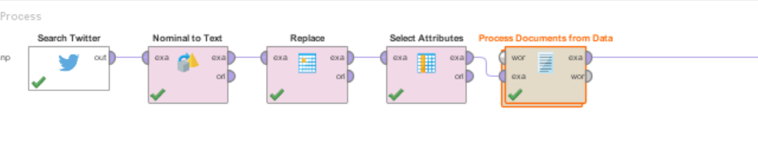

Process Documents from Data in RapidMiner

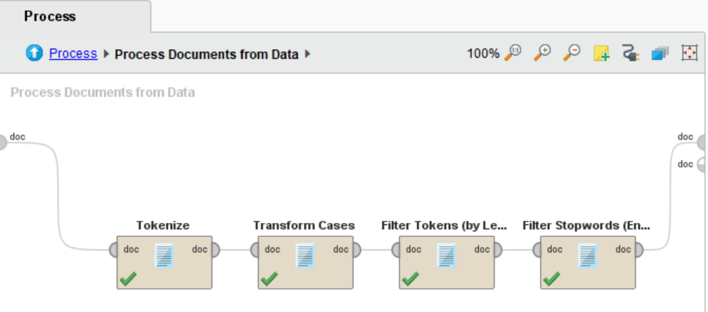

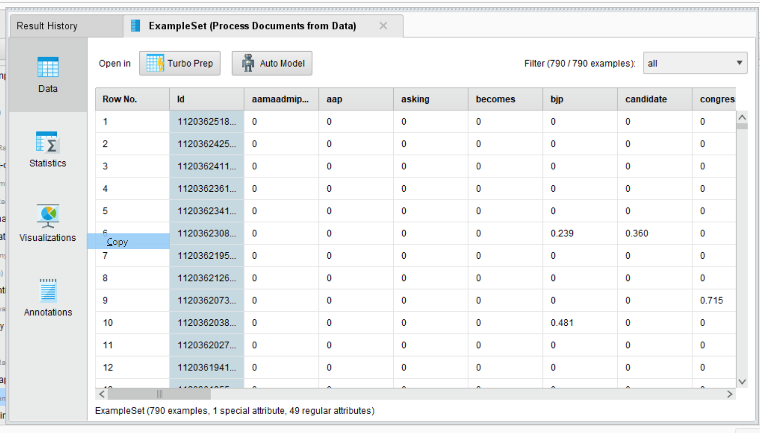

A pre-processing stage is necessary to clean (or remove the “noise” in) the data in preparation to build the model. Five operations were applied at the pre-processing stage, namely Tokenize, Transform Cases, Filter Token (Length) , Filter Stop wards (English). The following describes each operation in order of execution:
a) The Tokenize operator splits the texts of a document into a sequence of words (or tokens) by setting the nonletters mode as splitting points.
b) The Transform cases operator converts the characters in a document to lowercase so that the words, “Hello” and “hello” are the same.
c) The Filter Tokens (by Length) operator removes tokens based on their length. For instance, if the minimum and maximum characters are set to 3 and 25, respectively, then it will remove texts having less than 3 characters and more than 25 characters in length.
The Filter Stop words (English) operator removes the unwanted words from a document such as is, are, the, of, etc. These words are commonly used in the text but are deemed useless when used because it provides no content information.
This operation makes the comparison between words easier. The result of the Process document operator is a list of words with total and document occurrences. In this case, the operation produces 49 word list i.e. 790 examples with 1 special attribute ,49 regular attributes.

A Term Frequency-Inverse Document Frequency (TF-IDF) score, which is the weighting factor, is assigned to each attribute in order to identify its significance to a document in a corpus. Choose TF-IDF to tokenize the words, and eliminate those scanty words or prevalent words

A TFIDF score of 0 indicates that the term did not appear in a document, whereas a TF-IDF score of 0.617 means that the term is significant as opposed to a TF-IDF score of 0.283.

Modelling

Use K-Means Clustering to group tweets into cluster that have similar keywords. Determine the k value i.e. number of clusters
Clustering is one of the commonly used unsupervised learning methods in analysing the context of text data in natural language form It is a mathematical approach in collecting and segmenting similar documents into clusters. It helps trim down the volume of unstructured text and provide a simpler understanding and thematic structure of the data. It also provides the keywords in each cluster that is useful in extracting valuable insights, hence, customer sentiments can be summarized using these keywords .K-means is a clustering technique in cluster analysis that finds a user-specified number of clusters that are represented by their centroids.

The basic k-means algorithm is described as:
- Select k points as initial centroids
- Repeat
- Form k clusters by assigning each point to the closest centroid
- Recompute the centroid of each cluster
- Until centroids do not change
The algorithm iteratively assigns each point to one of the k groups based on the specified features and the points are clustered based on feature similarity . Firstly, the points are assigned to initial centroids. Each point is assigned to the nearest centroid and the centroid of that cluster is updated by computing the mean of all points that are assigned to the centroid’ cluster. This process is repeated until a stop criterion is satisfied.
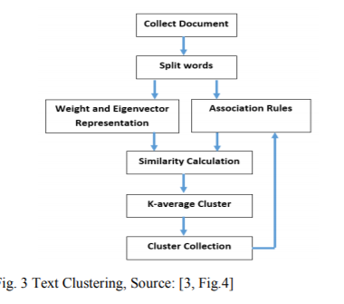
The algorithms starts with initial estimates for the Κ centroids, which can either be randomly generated or randomly selected from the data set. The algorithm then iterates between two steps:
1. Data assignment step:
Each centroid defines one of the clusters. In this step, each data point is assigned to its nearest centroid, based on the squared Euclidean distance. More formally, if ci is the collection of centroids in set C, then each data point x is assigned to a cluster based on
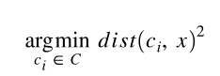
where dist( · ) is the standard (L2) Euclidean distance. Let the set of data point assignments for each ith cluster centroid be Si.
2. Centroid update step:
In this step, the centroids are recomputed. This is done by taking the mean of all data points assigned to that centroid's cluster.
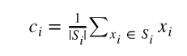

The algorithm iterates between steps one and two until a stopping criteria is met (i.e., no data points change clusters, the sum of the distances is minimized, or some maximum number of iterations is reached).
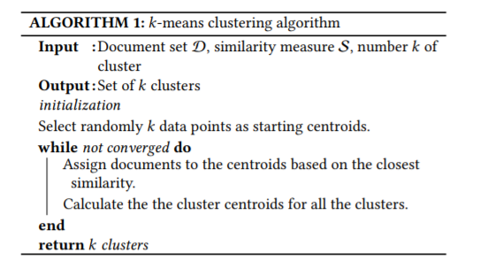

The clustering process uses the k-means operator. Since clustering is categorized as an unsupervised learning, it does not need a label attribute. K-means is efficient even with multiple runs. This experiment performed 10 repeated run times. It simply determines the set of k clusters and assigns each example to a specific cluster .

The main disadvantage of k-means clustering is that it is very sensitive to the initial choice of the number k .Thus there are some techniques used to determine the initial k ,using another lightweight clustering algorithm such as agglomerative clustering algorithm.

Selection of K in k-means clustering
The K-means algorithm is a popular data clustering algorithm. To use it requires the number of clusters in the data to be pre-specified. Finding the appropriate number of clusters for a given data set is generally a trial-and-error process made more difficult by the subjective nature of deciding what constitutes ‘correct’ clustering
In general, there is no method for determining exact value of K, but an accurate estimate can be obtained using the following techniques. One of the metrics that is commonly used to compare results across different values of K is the mean distance between data points and their cluster centroid. Since increasing the number of clusters will always reduce the distance to data points, increasing K will always decrease this metric, to the extreme of reaching zero when K is the same as the number of data points. Thus, this metric cannot be used as the sole target. Instead, mean distance to the centroid as a function of K is plotted and the "elbow point," where the rate of decrease sharply shifts, can be used to roughly determine K.
A number of other techniques exist for validating K, including cross-validation, information criteria, the information theoretic jump method, the silhouette method, and the G-means algorithm. In addition, monitoring the distribution of data points across groups provides insight into how the algorithm is splitting the data for each K.
- Values of K specified within a range : Reported studies on K-means clustering and its applications usually do not contain any explanation or justification for selecting particular values for K. Table 1 lists the numbers of clusters and objects and the corresponding data sets used in those studies.
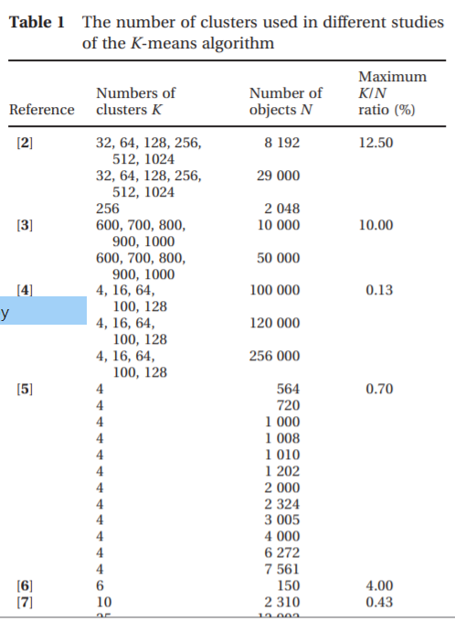

- Values of K specified by the user : The K-means algorithm implementation in many data-mining or data analysis software packages [19–22] requires the number of clusters to be specified by the user. To find a satisfactory clustering result, usually, a number of iterations are needed where the user executes the algorithm with different values of K. The validity of the clustering result is assessed only visually without applying any formal performance measures. With this approach, it is difficult for users to evaluate the clustering result for multi-dimensional data sets.

The number of tweets in each cluster, the end process generated five clusters with corresponding items: Cluster 0 with 652 items, Cluster 1 with 0 items, Cluster 2 with 80 items, and Cluster 3 with 49 items and Cluster 4 with 119 items, and Cluster 5 with 62 items. The words in each cluster provide insights on what the cluster is all about.
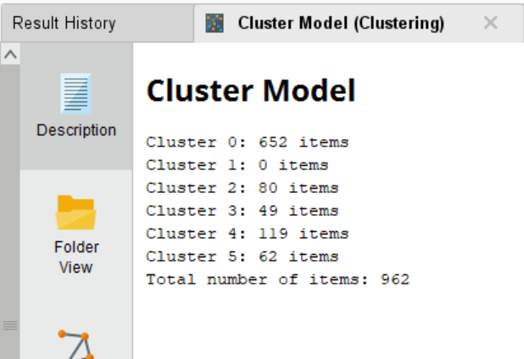
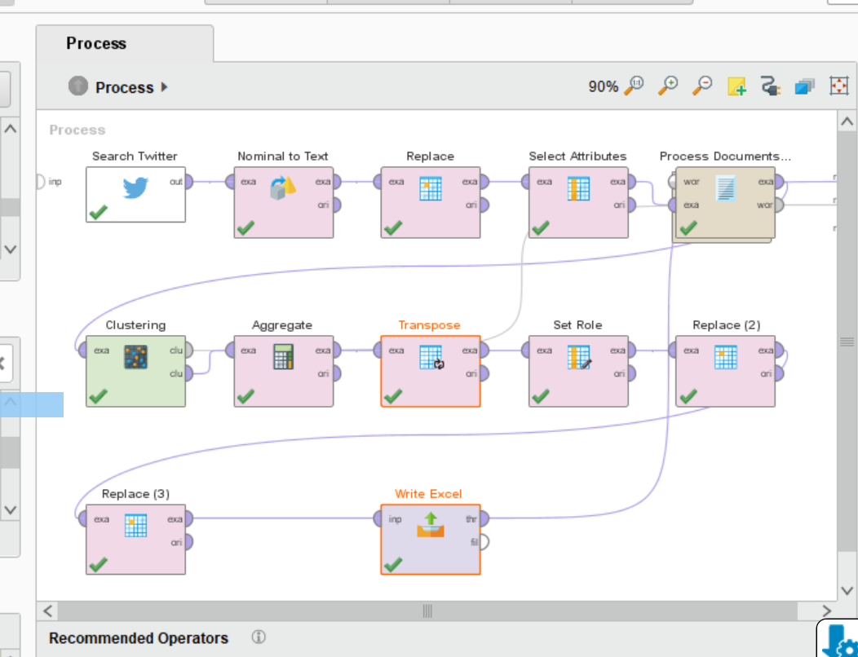

Aggregate the collected results to identify the top keywords in each cluster. Calculate the average TF-IDF of each word in all clusters and transpose the result. All the words are saved in the ID Column in the clustering result, change the role of ID to regular so we can edit the output. All the derived results are stored in a CSV file

Evaluation :
The results generated depicts the popular keywords in different clusters in the rapid miner
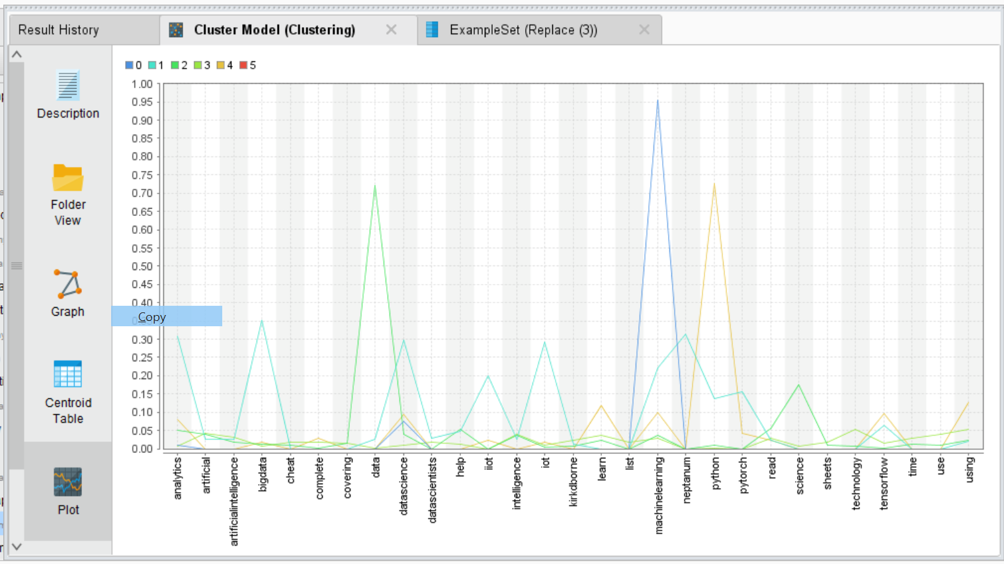

User can sort the average TF-IDF score of the words in each cluster to see what keyword are more popular in those clusters. Id column in the figure below are the top keywords in the last cluster. The final outputs where the average TF-IDF scores of all words in each cluster are calculated.

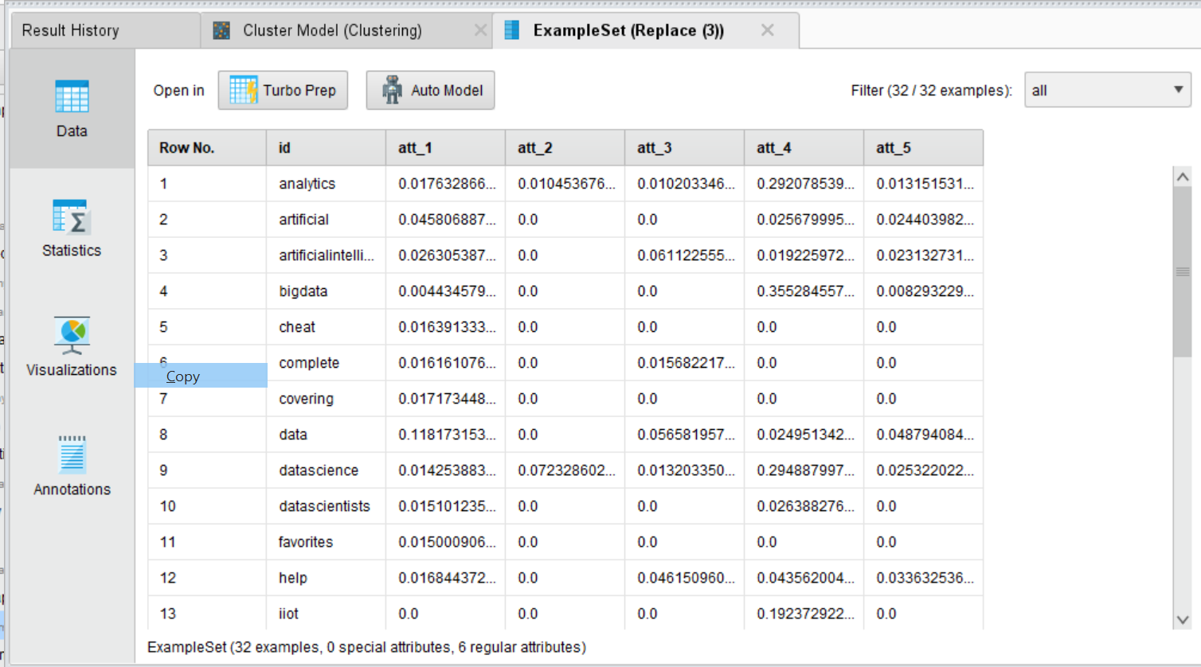

Deployment
The processed saved file is then deployed in tableau to provide insight of the data based on the business requirements for decision making or further analysis. Word Cloud are created for all clusters by substituting the average TF-IDF of the first cluster with other clusters. By enabling filtering function we can check the keywords across clusters.

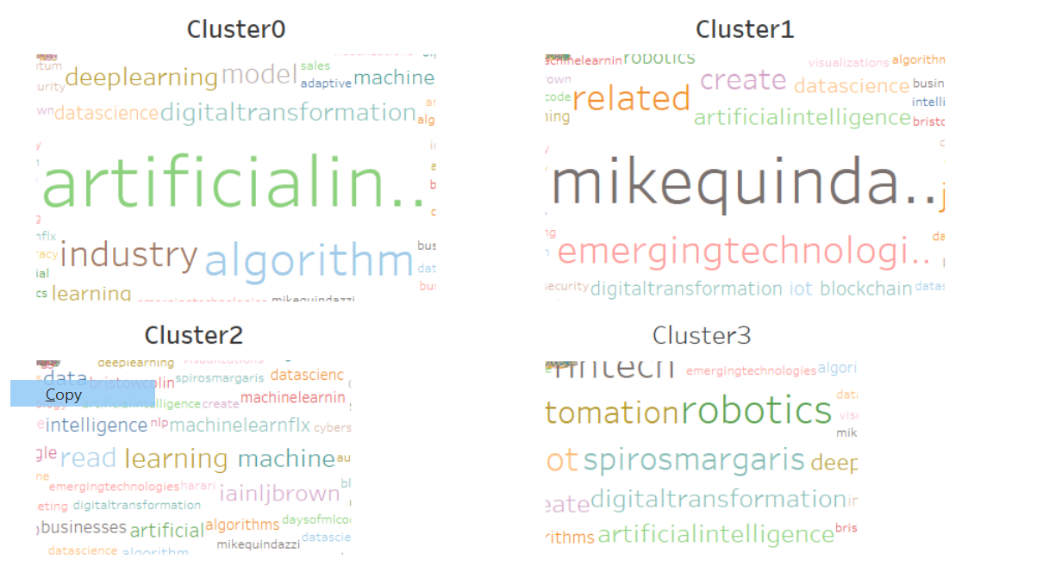

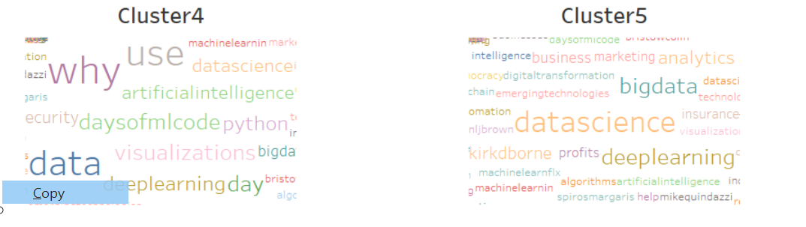

Future Works: The saved file can also be deployed in R shiny app-An interactive approach to tell data story with shiny. Let users interact with data and analysis. Shiny is an R package that makes it easy to build interactive web apps straight from R.

Conclusion :
The outcome of evidence-based decision making contributes to the improvement of a brand. Having a text analysis of customer feedback and reviews allows effective quality management. This paper provided an introduction and rationale behind the value of text analytics of Twitter data to businesses in gaining customer views on products and services, and brand.

Future work in this field can also be focused on Realtime analytics of Twitter data stream. Since there is a massive amount of tweets collected daily, handling real-time analytics is difficult. Therefore an automated analysis which runs in high processing and large memory computing resources, is required.

References :
https://www.researchgate.net/publication/324360275_Application_of_Text_Classification_and_Clustering_of_Twitter_Data_for_Business_Analytics
https://www.researchgate.net/publication/312293790_Using_Text_Analytics_to_Derive_Customer_Service_Management_Benefits_from_Unstructured_Data
https://www.researchgate.net/publication/326098737_A_brief_survey_of_text_mining_Classification_clustering_and_extraction_techniques
https://www.sciencedirect.com/science/article/pii/S2090447914000550
https://www.academia.edu/22640898/Text_Analytics_the_convergence_of_Big_Data_and_Artificial_Intelligence

